Iggy Kaneff, builder and philanthropist, receives one of nation's highest honours

Kaneff was awarded the Order of Canada for his community dedication and service to the nation
News Jan 25, 2017 by Rachael Williams Mississauga News
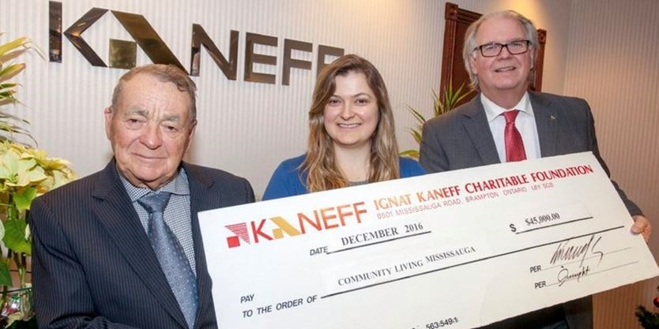
Ignat (Iggy) Kaneff, founder of Kaneff Corporation, and his daughter Kristina Kaneff, president of the Kaneff Charitable Foundation, present a cheque for $45,000 to Eugene Nolin, President of the Board of Directors, Community Living Mississauga at the Kaneff Corporation headquarters in Brampton. - Metroland file photo
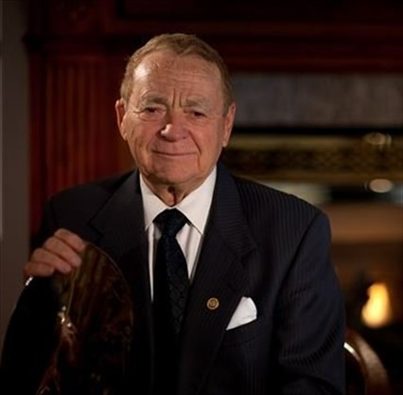
Ignat, or "Iggy" Kaneff, has been awarded the Order of Canada, the country's most prestigious award for dedication to the community and service to the nation. - Metroland file photo
1 / 2
Iggy Kaneff, the “little Bulgarian immigrant” that built a real estate empire, can now add the Order of Canada to his growing list of accolades.
“This is the real McCoy” he says, pointing to his stylized six-pointed snowflake insignia he has pinned on the left side of his sport coat.
The Order of Canada recognizes outstanding achievement, dedication to the community and service to the nation. The motto inscribed on the insignia is "Desiderantes meliorem patriam," which means "they desire a better country."
That's never been more true than for Iggy Kaneff.
The 90-year-old real estate magnate has helped build hospitals, schools, community centres, homes and apartment buildings. He also established the Ignat Kaneff Charitable foundation in 1986 to support education, health, the arts and social services of local communities.
Iggy has been an invaluable contributor to Community Living Mississauga, the Credit Valley Hospital Foundation, Mississauga Symphony Orchestra, University of Toronto in Mississauga, Osgoode Law School building campaign and the Lassonde School of Engineering building campaign at York University.
“My philosophy is to support the community,” he says. “I always try to give back whatever I can.”
Iggy’s generosity and philanthropic spirit comes from his humble beginnings. At 24-years-old, Iggy immigrated to Canada from Bulgaria with $5 in his pocket and no grasp of the English language.
“They used to steal people on the street in Bulgaria and force them into the army,” he recalls. “I was very fortunate I was able to come to Canada.”
With no job prospects and only one friend in the country at the time, Iggy was eager to take on any opportunity that came his way.
That opportunity came from the father of Harold Shipp, one of Mississauga’s most influential developers. Iggy worked as a labourer for the Shipp Corporation during the day and at night, washed cars in Toronto.
He quickly attained his carpenter’s licence, which garnered him a raise at the Shipp Corporation, making $2 per hour. He managed to scrape together $300 and, coupled with a loan he received from a woman he had helped with yard work, Iggy bought a lot in Lakeview where he built his first house before his 26th birthday.
Borrowing against his home, Iggy built a second home, and then another, and another.
After only one year of being in Canada, he had made enough money to quit his job at the Shipp Corporation and start his own construction company, Kaneff Properties Limited.
“Iggy Kaneff helped plant the seeds that would see Mississauga grow from farm fields and fruit trees into the vibrant, prosperous, and thriving place we now call home,” said Mississauga Mayor Bonnie Crombie.
His portfolio includes 45 highrise buildings, residential subdivisions, commercial plazas and six golf courses, including Lionhead Golf and Country Club.
But for Iggy, it was never about how many buildings bore his name, but about the lives he touched and the difference he was able to make in his community.
He recalls making his first charitable donation to help build the South Peel Hospital, which later became known as The Mississauga Hospital.
“I donated $2,000 and at the time (1956), I didn’t even have the money,” he laughed.
It was the highest donation given to the project.
Remembering how good it felt to be the “little Bulgarian immigrant” that was quickly becoming one of Mississauga’s most philanthropic community builders, Iggy tried to get involved in as much charity work as possible.
“He is truly just a warm, very kind man who believes in people and the gifts people have and he appreciates coming here as an immigrant and being given opportunities,” said Debbie Moffat, director of quality and community development for Community Living Mississauga, a non-profit charitable organization that provides support to those with intellectual disabilities.
Iggy is an anchor supporter of Community Living Mississauga and holds an annual golf tournament, donating all proceeds to the organization. Over the years, it has raised $1.3 million.
“Its so hard for us to say thank you for everything he does,” said Moffat. “There’s no man with a bigger heart.”
Iggy has been the recipient of the Order of Ontario, three honorary Doctor of Laws degrees, along with an honorary degree from Sheridan Mississauga. He was also Businessman of the Year for the City of Mississauga and Brampton, Mississauga Citizen of the Year, recipient of the Canada 125 Medal and the Queen’s Golden Jubilee Medal, the Mississauga Heritage Lifetime Achievement Award and the Community Living Mississauga Lifetime Achievement Tribute.
As far as business goes, Iggy is still purchasing land for future developments, running his company with the help of his family and a staff of 300. His wife Didi is president of Kaneff Properties. His two daughters, Anna-Maria and Kristina, serve as vice president of business development and investments, and general counsel, respectively.
Asked if he plans to retire any time soon, Iggy laughs.
“No way, I got another 15 years of this.”

by Rachael Williams
Rachael Williams is a reporter with The Mississauga News and Brampton Guardian. She can be reached at rachaelwilliams@metroland.com . Follow her on Twitter and the Mississauga News on Facebook
Email: RachaelWilliams@metroland.com Facebook Twitter

